SCHOOL

Trial WACE Examination, 2010

Question/Answer Booklet

MATHEMATICS 2C/2D(1)
SOLUTIONS

Section Two:

Calculator-assumed

Student Number: In figures

In words

Your name

Time allowed for this section
Reading time before commencing work: 10 minutes
Working time for paper: 100 minutes

Material required/recommended for this section

To be provided by the supervisor
This Question/Answer booklet
Formula sheet (retained from Section One)

To be provided by the candidate
Standard items: pens, pencils, pencil sharpener, eraser, correction fluid, ruler, highlighters

Special items: drawing instruments, templates, notes on two unfolded sheets of A4 paper, and up to three calculators satisfying the conditions set by the Curriculum Council for this course.

Important note to candidates

No other items may be used in this section of the examination. It is your responsibility to ensure that you do not have any unauthorised notes or other items of a non-personal nature in the examination room. If you have any unauthorised material with you, hand it to the supervisor before reading any further.

Structure of this paper

Section | Number of questions available | Number of questions to be answered | Working time (minutes) | Marks available
Section One:  Calculator-free | 7 | 7 | 50 | 40
Section Two:  Calculator-assumed | 10 | 10 | 100 | 80
 |  |  |  | 120

Instructions to candidates

- The rules for the conduct of Western Australian external examinations are detailed in the Year 12 Information Handbook 2010. Sitting this examination implies that you agree to abide by these rules.

- Write your answers in the spaces provided in this Question/Answer Booklet. Spare pages are included at the end of this booklet. They can be used for planning your responses and/or as additional space if required to continue an answer.
- Planning: If you use the spare pages for planning, indicate this clearly at the top of the page.
- Continuing an answer: If you need to use the space to continue an answer, indicate in the original answer space where the answer is continued, i.e. give the page number. Fill in the number of the question(s) that you are continuing to answer at the top of the page.

- Show all your working clearly. Your working should be in sufficient detail to allow your answers to be checked readily and for marks to be awarded for reasoning. Incorrect answers given without supporting reasoning cannot be allocated any marks. For any question or part question worth more than two marks, valid working or justification is required to receive full marks. If you repeat an answer to any question, ensure that you cancel the answer you do not wish to have marked.

- It is recommended that you do not use pencil except in diagrams.

Section Two: Calculator-assumed (80 Marks)
This section has ten (10) questions. Answer all questions. Write your answers in the space provided.

Working time for this section is 100 minutes.

Question 8 (8 marks)
(a) A sequence is defined by 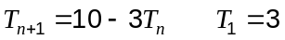. Calculate the first 6 terms of this sequence. (2 marks)

3, 1, 7, -11, 43, -119

(b) A second sequence begins 117, 113, 109, 105, ...

(i) Express this sequence using a recursive rule. (2 marks)
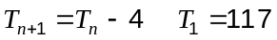

(ii) How many terms of this sequence are positive? (1 mark)
30 terms

(c) Each term of a third sequence is 6% greater than the previous term. If the first term is 50, which term of the sequence is approximately double this number? Justify your answer.
(3 marks)
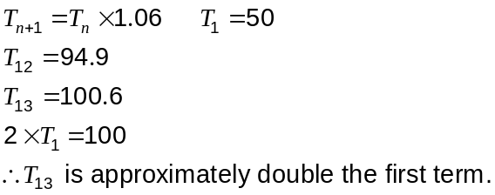

Question 9 (6 marks)
This diagram shows the flow capacity, in thousand of litres per hour, of pipes which connect points in an irrigation system.
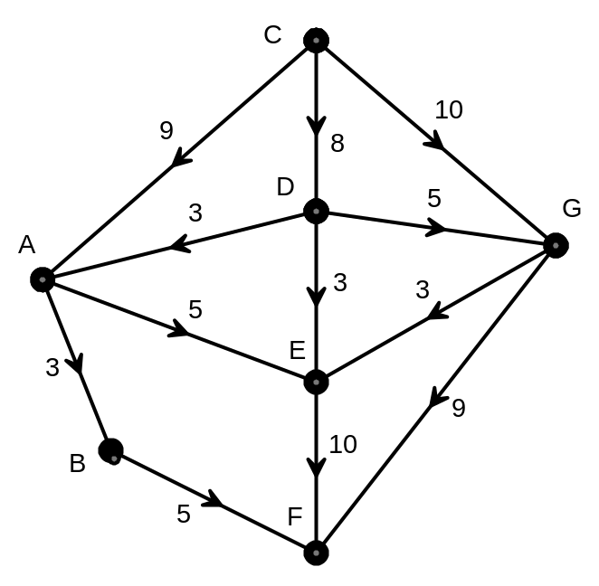

(a) Identify the source and sink for this network (1 mark)
Source is C. Sink is F.

(b) Find the maximum flow through the network from source to sink. You must show systematic working to obtain full marks. (4 marks)
CABF = 3
CAEF = 5
CDEF = 3
CDGEF = 2
CGF = 9

Total = 22

Maximum flow = 22 000L

(c) The flow capacity of pipe AE is increased by 3kL. What effect does this have on the maximum flow through the system? (1 mark)

No change.
(No spare flow in EF)

Question 10 (8 marks)
The depth of water in a flask in a science experiment was measured for an eight hour period and followed the rule 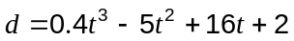, where was the number of hours since the experiment began and the depth of water in centimetres.

(a) What was the depth of water when the experiment began? (1 mark)
2cm

(b) Graph on the axes below. (3 marks)
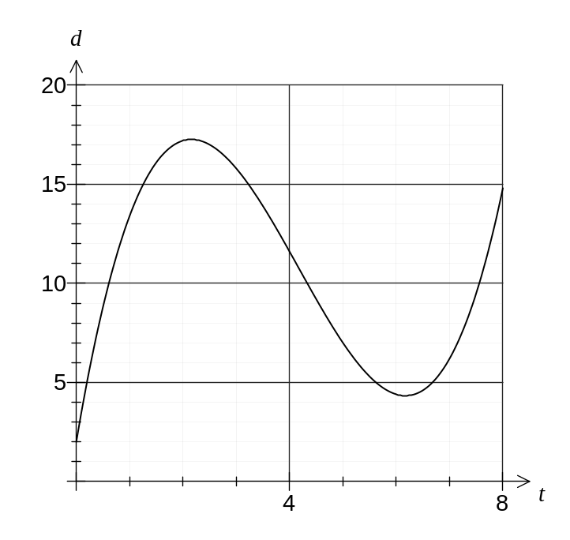
(c) For how many hours was the depth 10cm or more during the eight hour period? (2 marks)
From t = 0.61 to t = 4.33: 3.72 hours
From t = 7.56 to t = 8: 0.44 hours
Total 3.72 + 0.44 = 4.16 hours.

(d) What was the minimum depth of water during the first eight hours? (1 mark)
2cm

(e) At what time, correct to 2 decimal places, was the depth a maximum during the first eight hours? (1 mark)
t = 2.16 hours

Question 11 (8 marks)
(a) The table below, based on figures from the Australian Taxation Office, shows the tax rates for a recent financial year.

Taxable income | Tax on this income
$1 – $6,000 | Nil
$6,001 – $34,000 | 15c for each $1 over $6,000
$34,001 – $80,000 | $4,200 plus 30c for each $1 over $34,000
$80,001 – $180,000 | $18,000 plus 40c for each $1 over $80,000
$180,001 and over | $58,000 plus 45c for each $1 over $180,000

(i) Calculate the income tax payable by a person with a taxable income of $64 440.
(2 marks)
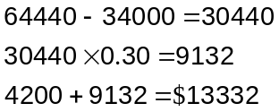

(ii) If the income tax payable by a person amounted to $1875, how much was their taxable income? (2 marks)

Choose 2nd row of tax table, as tax < $4200
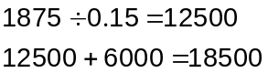

(b) A bank is offering two different types of personal loan for any customer who borrows between $500 and $10 000. One loan is based on a flat rate of 9.9%pa whilst the other loan adds 8.5% interest annually on a compounding basis.

A customer plans to borrow $4000 and repay the loan and interest in full after five years. Which of the two loans do you recommend they use? Justify your answer. (4 marks)
Using simple interest
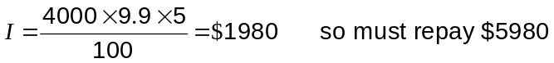

Using compound interest
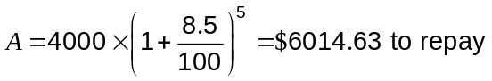

Hence choose simple interest loan, as the total to repay after five years is less than the compound interest loan.

Question 12 (7 marks)
The diagram below (not to scale) shows the line AG cut by the line DB at C and the line DF at E. The lengths of some of the sides are shown in centimetres.
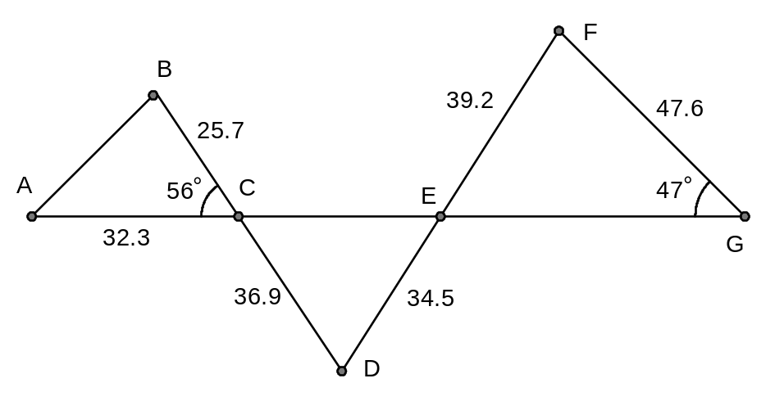
Showing use of trigonometry,

(a) Find the length AB. (2 marks)
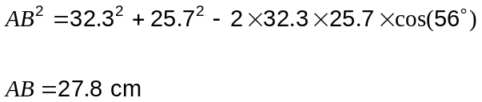

(b) Find the size of angle FEG. (2 marks)
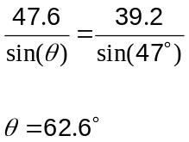

(c) Find the area of triangle CDE. (3 marks)
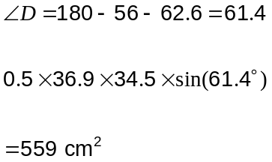

Question 13 (12 marks)
A local council is interested in what the local ratepayers think of the services it provides. The council is considering two different feedback forms, Form A and Form B. It has decided to trial each form using a random sample of 50 ratepayers drawn from the 6475 in its database.

(a) An extract from a table of four-digit random numbers is shown below:
2659 7283 3432 1335 0196 3692 8396 6852 2941 6295

(i) Choose one of the numbers from the list and explain how the council could use it to select one of their ratepayers. (2 marks)

2659 - Number all the ratepayers from 1 to 6475 and then the first pick would be ratepayer number 2659.

(ii) How many numbers in the above list could be used to select a sample? Explain your answer. (2 marks)
7 of the numbers. 7283, 8396 and 6852 are all too big, exceeding the last ratepayer number 6475.

(b) The council sent out copies of Form A to a sample of 50 ratepayers and 42 of these were returned by the required date. Each ratepayer was asked how long they took to complete the form and the times are summarised in the histogram below:
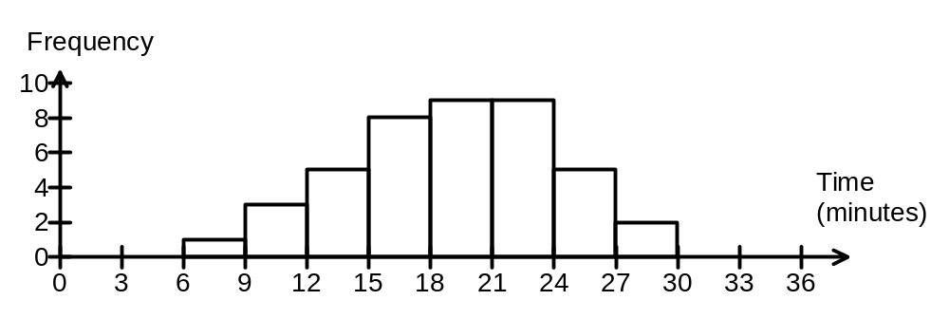
Calculate the mean and standard deviation for the time taken to complete Form A.
(2 marks)
Mean = 19.1 minutes

SD = 5.0 minutes

(c) The council also sent out copies of Form B to another sample of 50 ratepayers and 43 of these were returned by the required date. The mean time to complete Form B was 12.8 minutes, with a standard deviation of 5.41 minutes. The times are summarised in the histogram below:
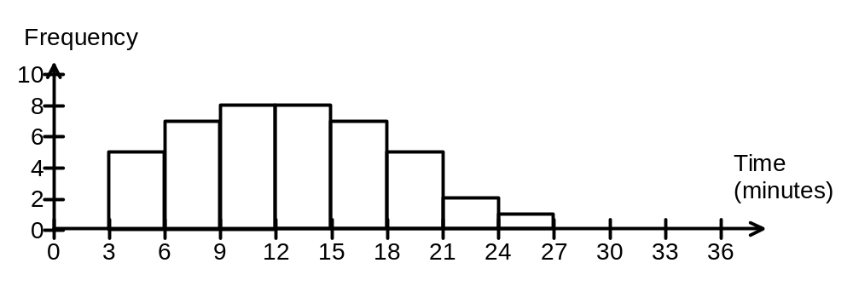

(i) Explain which of the two forms has the longest average completion time. (1 mark)
Form A takes longest, as it has a greater mean time (19.1 minutes) compared to Form B (12.8 minutes).

(ii) Which form has more variation in completion time? Justify your answer with appropriate statistics. (2 marks)

Form B has slightly more variation in times with a standard deviation of 5.41 minutes compared to only 5.0 minutes for Form A.

(d) The council know from past experience that the quicker a form is to complete, the more responses they are likely to receive and that the less variation in time to complete a form, the more reliable the responses are. Which form would you recommend the council use? Justify your answer. (3 marks)
Form B has a mean time that is considerably less than that of Form A (6.3 minutes less) which means B is much quicker to complete.

Form A has a slightly smaller sd than Form B (0.4 minutes less) which means A will generate slightly more reliable responses.

The small difference in sd's could be a result of the sampling and so recommend that the council use Form B as it is quicker to complete and is likely to generate as reliable results as Form A.

Question 14 (11 marks)
116 students from a school were asked whether they had Facebook or Twitter accounts. 93 said they had Facebook accounts (set F), 31 said they had Twitter accounts (set T) and 10 students said they had neither.

(a) Draw a Venn diagram for the above information. (4 marks)
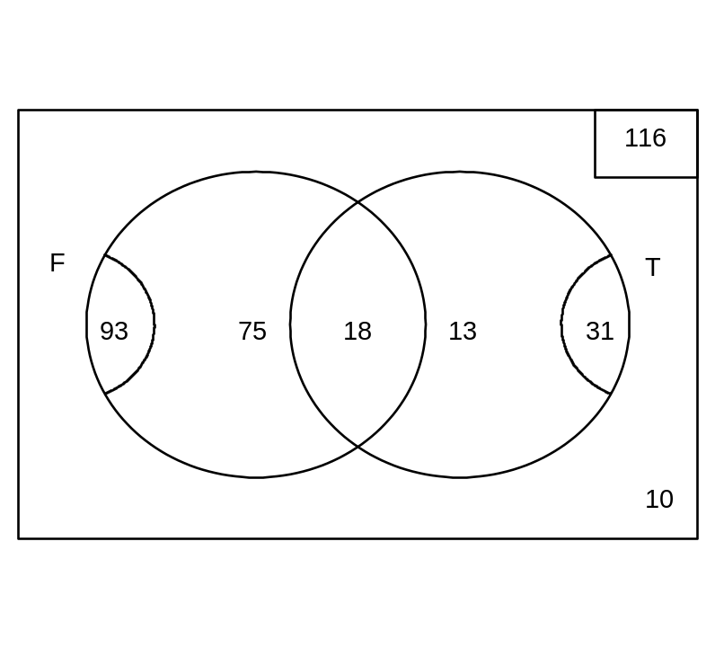
(b) How many students are in the set ? (1 mark)
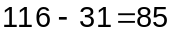

(c) Use set notation to state the number of students who have Twitter accounts but not Facebook accounts. (2 marks)
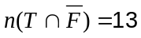

(d) Determine the probability that a student has a Facebook account if it is known that they had just one type of account. (2 marks)
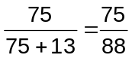

(e) If the 116 students were a random sample drawn from the 1180 students at the school, use the above data to estimate how many students at the school had Facebook accounts.
(2 marks)
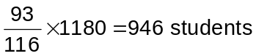

Question 15 (5 marks)
The first 12 Fibonacci numbers are 1, 1, 2, 3, 5, 8, 13, 21, 34, 55, 89 and 144, where 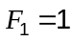, 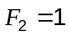, 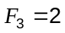, and so on.

(a) Complete the two rows below. (2 marks)

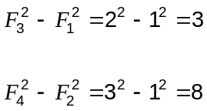

(b) A conjecture is made that for all Fibonacci numbers 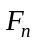, the difference 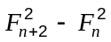 always results in a Fibonacci number.

(i) Explain how the two rows in part (a) support this conjecture. (1 mark)

The first row results in a difference of 3, which is 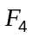 and the second row results in a difference of 8, which is 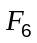.

(ii) Determine whether the conjecture is true or false, supporting your answer either with a counter-example or two examples (other than those in part (a)) for which the conjecture holds. (2 marks)
True.

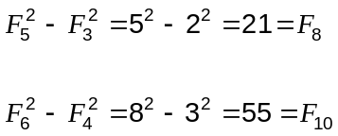

Question 16 (8 marks)
(a) In the frequency table below the range is 16, 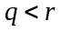, 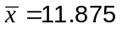 and 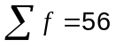.

Score () | Frequency (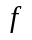)
5 | 8
9
12 | 21
 | 10
 | 5

Determine the values of , and . (4 marks)

Using the range
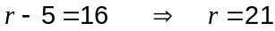

Using sum of frequencies

Using mean
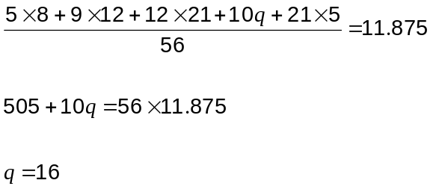

(b) The number of points scored in a game by each of the eleven members of a sports team are contained in the following list:

{ 12, 19, 14, 7, 15, 65, 6, 18, 21, 7, 16 }

(i) Explain why only one of the mode, median or mean is a suitable measure of central tendency for this data. Clearly state why the other two measures are not suitable.
(3 marks)
Median is suitable as it is not affected by the outlier of 65.

Mean will be too high due to the presence of the outlier.

Mode of 7 is unrepresentative and is generally unsuitable for data sets with only a few values.

(ii) Calculate the suitable measure of central tendency. (1 mark)
Median = 15

Question 17 (7 marks)
A teacher has to fill three parts in a school play from a shortlist of four students. The parts are for a doctor, a patient and a driver. The four students to choose from consist of two girls called Ann and Carol and two boys called Bob and Dave. There are no restrictions on who can play which part, except that if Carol gets a part then so must Ann.

(a) Draw a tree diagram to illustrate the possible combinations of parts and actors. (3 marks)
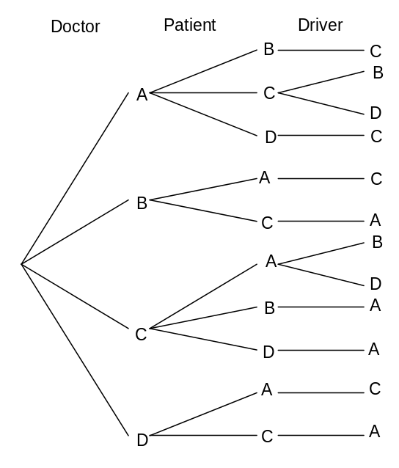

(b) Given that all combinations are equally likely, what is the probability that

(i) Bob gets a part? (1 mark)
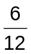

(ii) Carol does not get a part? (1 mark)
0

(iii) A boy plays the patient or the driver? (1 mark)
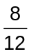

(iv) A boy plays the doctor given that a girl plays the driver? (1 mark)
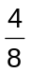

Additional working space

Question number(s):

Additional working space

Question number(s):

